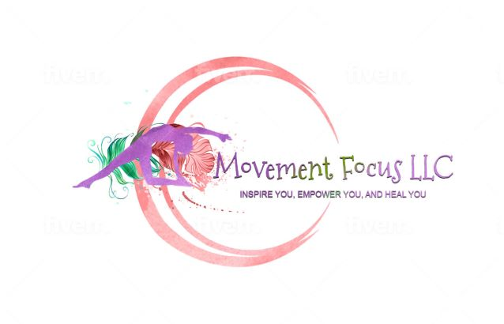
Carlton Landing Yoga
Academy - Administration/Cafeteria Bldg.
Fall Schedule
Monday 9:00 am (Outdoor sm. Pavilion)
Thursday 4:00 pm (cafeteria)

Saturday 9:00 am (pavilion-waterfront – location can vary -see website)
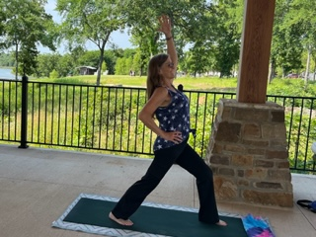
Instructor info:
Phyllis Parker-Bertun, B.S., A.C.E.,
E-RYT 500, Ayurveda Councilor
Website: www.movementfocus.com
Bus.#: 918-900-2750
Cell: 214-797-3416
E-mail: yttwpep@gmail.com
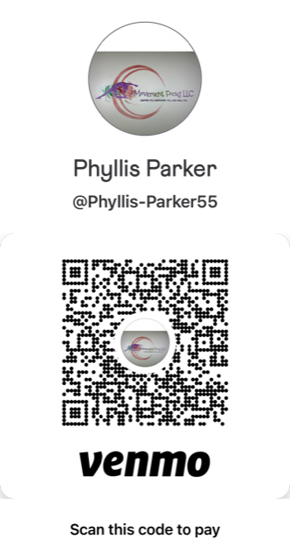
$15.00/class
Weekly rate 2 classes = $26.00
Payment options: Cash, check, Venmo, apple
Venmo: Phyllis Parker @Phyllis-Parker55

Private Event Bookings
Women’s Church retreat, glamping, girls weekend, or other celebrations.
Meditations can focus on a theme, scripture, your specifications.
8-10 people $125.00 12-20 people $210.00
book through www.movementfocus.com, call, text: 918-900-2750, E-mail: yttwpep@gmail.com

